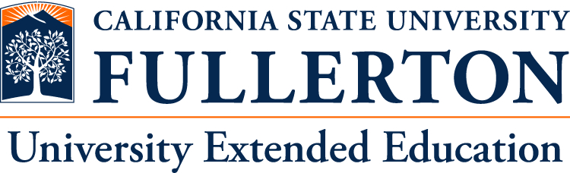

K-12 Education Seminar
for Student Teachers
from Shanghai Normal University

Sep 30 – Oct 11, 2013
(12 Days)

California State University Fullerton
University Extended Education
SEMINAR SCHEDULE
1st Week
Day 1 – Monday (Martin Luther King, Jr. Holiday – campus closed) – Los Angeles to Fullerton
 | Arrival at Los Angeles, Airport Pickup and Hotel Check in
Day 2 – Tuesday – Fullerton
9:30AM-10:30AM | Campus Tour: Mihaylo Hall, Pollak Library, Titan Student Union, Arts Center, Student Recreation Center
10:30AM-11:00AM  Location: | Program Overview
11:00AM-12:00PM  Location: | Orientation
12:00PM-2:00PM  Location: | Welcome Ceremony/Reception
2:00PM-4:00PM  Location: | Seminar: Overview of American Culture  This seminar will focus less on a history of America and more on the historical development of a belief system that affects American culture even today from politics to foreign policy to family life and education.
Day 3 – Wednesday – Fullerton
9:30AM-11:30AM  Location: | Seminar: Effective Classroom Management Techniques  Students learn best when their minds are actively engaged in creating meaning. They never arrive to class as “blank slates” for a teacher to write on, but always have some relatively naïve or sophisticated understandings to start with. Learn methods to engage students and ensure active learning in your classrooms by leading them to challenge themselves in confrontations with new information and ways to make sense.
1:30PM-3:30PM  Location: | Seminar: Overview of K-12 Education System in the U.S  What is the big picture of education in the U.S.? This seminar will provide an overview understanding of the institution of K-12 education, looking at numbers, historical trends, the relationships which schools must manage and the big picture of economic and political support for education.
Day 4 – Thursday – Fullerton
Visit:
- USC (University of Southern California – a private research university)
- UCLA (University of California Los Angeles – a public research university)
- Getty Museum
- Santa Monica Pier and Downtown
Day 5 – Friday – Fullerton
9:30AM-11:30AM  Location: | Seminar: Integrating Technology and Learning  This seminar will explore transformations which have occurred and can occur in K-12 classrooms as the result of developments in information technology. We will explore examples of how learning can be enhanced by thoughtful incorporation of both technologies and students’ own expertise in using them.
1:30PM-5:30PM  Location: | School Tour and Seminar: Teachers’ Professional Development in US  A teacher’s development only starts once a graduate moves into the classroom. This class will define professional development and explain the framework for having effective professional development in public education with special emphasis on Beginning Teacher Support and Assessment (BTSA).The seminar will explore the range of professional development activities and opportunities, and how these relate to professional requirements in the field. It will take place at a K-12 facility and will incorporate a tour.
Day 6 – Saturday - Weekend Activities
9:00AM-7:00PM | Universal Studios
Day 7 – Sunday - Weekend Activities
9:00AM-7:00PM | Disneyland Theme Park
2nd Week
Day 8 – Monday – Fullerton
9:30AM-11:30AM  Location: | Seminar: Multi-Cultural Curriculum Design  Different cultural traditions provide students with different understandings and approaches to the institution of school as well as to behavior in the classroom. All individuals lead with different modalities for learning, depending on their learning “style.” Cultural preferences can often exaggerate differences in learning approaches, and therefore in accomplishment. Learn about how to take advantage of a student’s starting point to ensure the most effective transition to the language and norms of the optimal learning environment.
1:30PM-3:30PM  Location: | Seminar: Instructional Strategies to Encourage Creative and Critical Thinking  In this workshop, participants will explore establishing classroom environments to support creative and critical thinking that engage students in active learning. Instructional models for encouraging students to become reflective of their reading, writing and thinking will be presented. Participants will have opportunities to design questioning strategies and class activities that support creative and critical thinking.
Day 9 – Tuesday – Fullerton
9:30AM-11:30AM  Location: | School Tour and Classroom Observations
11:30AM-1:30PM  Location: | Lunch and discussions with teachers
1:30PM-3:30PM  Location: | School Tour and Classroom Observations
Day 10 – Wednesday – Fullerton
9:30AM-1:30PM  Location: | School Tour and Classroom Observations
1:30PM-3:30PM  Location: | Roundtable Discussions with CSUF professors, supervising teachers and CSUF student-teachers
Day 11 – Thursday – Fullerton
9:30AM-11:30AM  Location: | Seminar: Teacher Training and Student Teaching in the US  This seminar will describe the process of teacher training in the US, and at Cal State Fullerton in particular. Future teachers normally receive degrees from academic departments and supplement their preparation with teacher-specific courses in pedagogy, and with student teaching assignments in local area schools.
2:30PM-4:30PM  Location: | Panel Discussion  Participants will have a chance to ask questions which they have developed over the course of their visit, and to engage in some discussion.
4:30PM-5:15PM  Location: | Graduation Ceremony
5:30PM-7:00PM | Farewell dinner
Day 12 – Friday – Los Angeles – China
 | Return to China
The above schedule is subject to change with prior notice.

